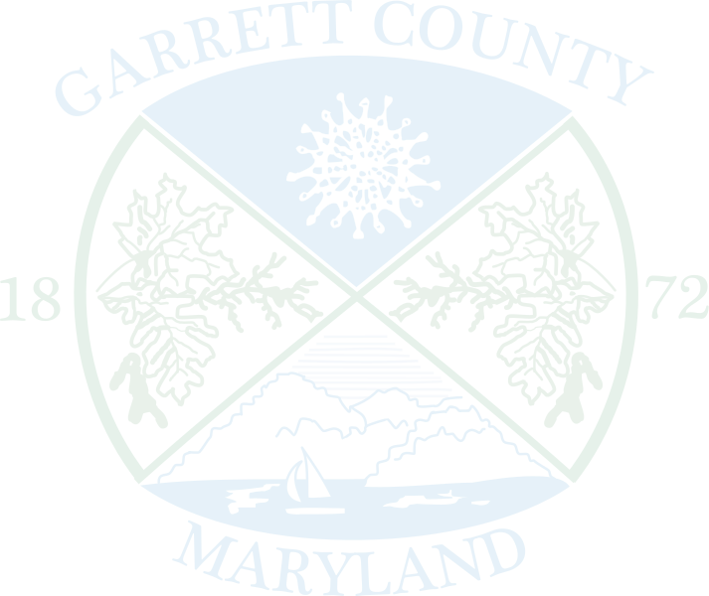


GARRETT COUNTY OVERDOSE PREVENTION TEAM
July 15, 2024– 9:00 a.m. (virtual only)
Meeting Minutes

Those Present: Mark Bishop, Derek Crippin, Chelsie Dever, Sadie Liller, Christian Mash, Avery Meyer, Jennifer Hare, Sandy Miller, Kevin Null, Fred Polce, Jr., Colt Ruby, Shannon Sexton, Melissa Clark, Jaimie Bell, John Corbin, Wayne Tiemersma

Christian called the meeting to order at 9:00 a.m.

The minutes for the May 13, 2024, OPT meeting were approved as submitted.

ANNOUNCEMENTS:
- There were no announcements.

DATA UPDATES – Community Drug Trends:
- Wayne Tiemersma and Derek Crippin shared they have seen a reduction in overdose rates in the last 6 months through EMS along with Narcan administrations. In 2023 there were approximately 27 suspectable overdoses from January to July 14, however, in 2024 there were only 22. There were 13 Narcan administered through EMS in 2023 but only 11 in 2024. They mentioned they have seen an uptick in Narcan being administered before EMS arrives.
- Chelsie Dever wanted the group to note we had an uptick in walk-ins during the first half of the year to the Health Department requesting Narcan and Fentanyl/Xylazine test strips.

Update on Opioid Settlement Funding (Local Abatement Plan)
- Kevin Null noted that the funds have been trickling in and we may need to do a timeline of when funds will be dispersed, however, we have not received final approval from the state office.
- Avery Meyer shared we will need final approval before we can disperse funds, but she will flag our grant to try and get approval soon.

Update on Overdose Prevention Team Grant
- Shannon recapped what was written into the grant for FY25. Operation Prevention will move forward another year allowing Garrett County students (4th, 7th, High school) to learn about SUD and how they can prevent it. The Community Resource Team will also move forward another year allowing the team to increase support between the general public, those in recovery, EMS and the resources our county offers. The final piece of the grant is for Oversight and Support to foster collaboration between like-minded coalitions and groups. It also supports Academic Detailing where we help inform physicians on best practices for prescribing opioids.

New Business:
- Opioid Restitution Funds Grant
  - Chelsie informed the group about a new competitive grant that the State of MD offers through Opioid Restitution Funds. We will be writing this grant in collaboration with multiple departments within the Health Department. Health Education and Outreach’s portion will be focused on the prevention aspects such as Afterschool prevention, parent education and expanded medication take-back events.

Community Updates:
- No Community Updates

Agency Updates
- Melissa Clark shared an update on the Syringe Service Program (SSP) coming to GC. Hoping to be implemented by Fall 2024, this will be a mobile service at least once a week with the main goal of connecting with people and making sure they are aware of community services. They have been testing the syringes to see what is the most prevalent issue and how we can help prevent those diseases. Melissa will present on the SSP at the September meeting.
- Melissa also shared info regarding Mountain Medical Mission. July 27- August 5, AHEC WEST is partnering with Mountain Laurel and the Army Reserves to offer 10 days of free services ranging from health care, dental care, treatment services, veterinary services, etc.
- Melissa shared AHEC West was a recipient of the HART grant which services specific zip codes in Allegheny and Garrett County to focus on heart disease and substance prevention over the next 5 years.
- Sandy Miller inquired about an update regarding the mobile crisis unit. Fred Polce verified it's been running since February but not full-time due to staffing issues.
- Jaimie Bell gave an update on Reflection House. Renovations are almost done, software to run the facility has been purchased and staff training will start in August. A projected facility open time for late September. Once training has been completed, they can apply for MCORE Certification which will help cover bed fees for 9 months. They will also launch a waiting list in August to prepare for admission in September.
- Jaimie also shared information regarding International Overdose Awareness Day which will be held at The Glades Pavilion on 8/31 from 6-8pm.

Public Comments:
- No public comments.

Other Comments:

Schedule next meeting: Meetings will continue to be virtual.
- Our next meeting will be held on Monday, September 16th at 9:00 a.m.

